1. Observation Systems

2. Principal Investigator: Steve Ruberg (60%)
3. Co-principal Investigators: Tom Bridgeman (Lake Erie Center), Dave Schwab, Tom Austin (Woods Hole), Stuart Ludsin, Mike McCormick
Co-workers: Ron Muzzi, John Lane, Terry Miller, Dave Fanslow, Greg Lang
4. Project Type: Continuing

5. Project Category E
6. April – December 2005
7. Percent of Effort in Theme Area:
- Environmental Prediction:
- Ecological Prediction: 30%
- Aquatic Invasive Species:
- Great Lakes Observing System: 70%

8. Executive Summary:

This proposal is intended to continue to build a programmatic and engineering research and development base to establish Great Lakes environmental observation networks. Great Lakes basin-wide, on-water observation networks will include the development of fiber optic cabled and high-bandwidth wireless systems utilizing advanced database management systems. In addition to advancing GLERL’s scientific real-time data acquisition capability, the project will make relevant data accessible to the public and educational institutions through a web-based data interface accessible using current internet technology. Permanent and portable wireless internet observation systems will be deployed at four sites in Lake Erie for the purposes of continued engineering development and scientific data collection. The GLERL internal Lake Erie project is intended to establish a permanent site in western Lake Erie at Light #2 and deploy a buoy 14 miles north of Cleveland in an area where hypoxia is likely to observed. This buoy will act as a relay station for two NOAA IOOS buoys deployed at locations to observe hypoxia and achieve a maximum range of approximately 30 miles.

9. Proposed Work (collaborators – Tom Austin (WHOI AUV), Dave Schwab (AUV), Tom Bridgeman (UT LEC), Mike McCormick, Stuart Ludsin et al)

The goals of the Lake Erie internal project:

- determine buoy and permanent system reliability
- demonstrate the capability to trigger sampling events using real-time observations
- demonstrate wireless internet system roaming, multiple access, and relay capabilities
- develop the capability to transmit high resolution imagery from buoy to field station
- AUV experiment

The goals of the NOAA IOOS project:

- expand the range of the current system to approximately 30 miles by implementing a relay buoy for data transmission
- develop a data management system that allows data archiving and real-time data display and web accessibility
- add the capability to take repetitive vertical profiles throughout the water column and expand the range capabilities of data transmission
One permanent wireless internet observation system will be deployed in the western basin of Lake Erie demonstrating event-triggered sampling and multiple access and and relay at navigation Light #2 as shown in figure 1. A prototype wireless internet buoy successfully deployed in 2003 and 2004 in the central basin of Lake Erie will again be deployed 14 miles north of Cleveland providing observations in collaboration with the NOAA IOOS project, Ecological Responses to Low Oxygen (Ludsin’s GLERL internal proposal) and the potential NOAA COP project. Parameters measured at all sites will include dissolved oxygen, chlorophyl a, PAR, turbidity, conductivity, temperature profiles, waves, and current profiles. All systems will be deployed with wave-measuring ADCPs, thermistor strings, and YSI multi-probes. WHOI/AOPE will collaborate with GLERL on an AUV experiment measuring currents, temperature profiles, and oxygen along the central basin of Lake Erie thermocline/oxycline for one week in July 2005. A goal of the project will be to integrate the AUV with the observing system in Lake Erie.

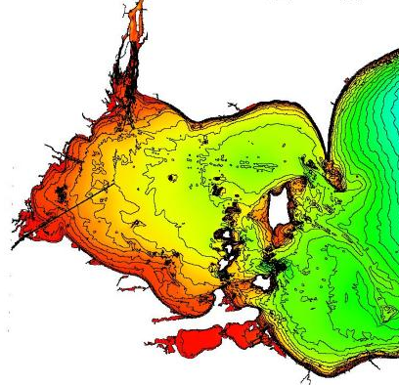

Light #2
Figure 1. Permanent wireless observation system located at Light #2.

10. Rationale:

An integrated environmental observatory will be capable of providing real-time observations of chemical, biological, and physical parameters. The system will allow data collection during extreme weather events, facilitate modification of sampling parameters in anticipation of episodic events, facilitate collection of biological and physical samples in response to episodic events, support long term research and support sensor and system development. The system will include a high bandwidth data link and underwater hub designed to allow expansion via satellite nodes. The system architecture will be designed to allow simple integration of sensors from various institutions through guest ports. Access to and control of instrumentation will be made available to the scientific community and educational institutions through the internet. The establishment of a system capable of real-time observations will support GLERL’s leadership of observation system activities among Great Lakes area universities and non-profit institutions.

The engineering research and development effort expended on this project has the potential to advance GLERL’s scientific data collection capabilities. A network of real-time data collection platforms can allow GLERL to respond to episodic events such as sediment re-suspension or cyclical biomass changes. Figure 2 is a plot of turbidity data collected hourly from an automated mechanical profiler in August, 2001 at Muskegon. The signal at the thermocline is associated with light attenuation related to plankton; the cyclical nature is attributed to an inertial influence. Sampling by an automated system at or above the Nyquist rate can provide a useful data set at the thermocline. However, the benthic signal is much more random in nature requiring a sampling rate that would make data collection very difficult. Real-time observation of an event such as this could allow sampling to be requested from a research vessel or initiated using automated methods.

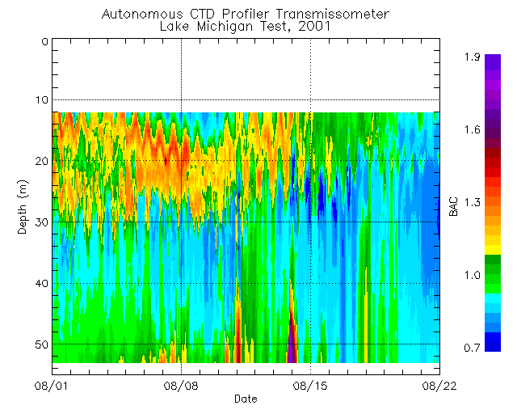

Figure 2

Real-time observations will improve data acquisition reliability. Data acquisition failures occur for reasons attributed to preparation error, water intrusion, or instrument loss due to a variety of causes. In real-time systems, instrument preparation errors can be detected immediately upon instrument deployment and corrected. When data is collected in real-time and archived, not only can failures be detected, but there is no loss of data due to instrument failure or loss.

Western Lake Erie

Real-time observations of turbidity and DO variability will be used to trigger GLERL and LEC sampling events. Western Lake Erie waters become thermally stratified during summer for periods ranging from 2 to 10 days. These stratification events often result in low oxygen concentrations near the sediments, which may, in turn, have adverse effects on benthic animals, especially mayfly larvae. Mayfly larvae are particularly important because they are a major component of yellow perch diets. Although there appears to be a correlation between high yearly stratification and mayfly reproductive failures, the mechanism behind this connection is unknown.

Real time temperature and oxygen data would allow us to identify stratification events as they are developing. During such events, we would be able to deploy divers or an ROV to observe mayflies under oxygen stress, answering questions such as: Does hypoxia kill mayflies outright? Or, does hypoxia drive mayflies from their burrows in search of oxygen?

See Ecological responses to low oxygen events in central Lake Erie proposal for additional Observing System rationale for western and central Lake Erie.

The Autonomous Vehicle experiment done in collaboration with Woods Hole Oceanographic Institution is intended to demonstrate the ability to provide continuous currents, temperature and oxygen profiles over a five day period in July. This project represents a valuable opportunity to provide broad spatial measurements over a significant time frame contributing to GLERL’s understanding of the dynamics of the hypolimnion in the central basin. The system will continuously provide measurements from 2 meters from the bottom to the surface covering a diameter of approximately 3 km along 4 transects with headings of 0, 45, 90, and 135 degrees for five days. This project will all prove the concept of integrating the AUV into the GLERL observing system network.

11. Government/Societal Relevance:

This project is relevant to NOAA’s strategic goal to enhance environmental observing and prediction systems and GLERL’s environmental and ecological forecast program areas. NOAA strategic goals relevant to this project are to protect, restore and manage the use of coastal and ocean resources through ecosystem management approaches and to serve society’s need for weather and water information.

A real-time observation system not only provides GLERL with an advanced scientific data collection capability but also allows research community and, in some cases, public access to environmental information. Figure 3 demonstrates that GLERL’s present real-time meteorological sites are seen as valuable sources of information to the public.

12. Relevance to Ecosystem Forecasting:

A network of observation systems can provide real-time input into ecological and physical models just as real-time meteorological data provides initial conditions for GLERL’s wave and circulation forecast research. Currently, real-time sensor inputs for wave and circulation nowcast and forecasts are input into the model six times per day. Real-time observations have the potential to allow a broad range of biological and chemical parameters to be measured and subsequently input into developmental and operational ecological forecast systems.

13. Links:

The proposed development will form the basis of a future observation network currently being planned by GLERL with the regional universities and the GLOS program.

14. Project Timeline:

Wireless observation systems in place by May 30, 2005.

15. Budget Request:

Funds for buoy prep, supplies and travel ($11,000 total) have been provided through the first internal proposal process. A collaborative agreement with the UM HydroLab is currently being pursued to contribute provide $10,000 for the AUV experiment; only $10,000 in GLERL funds would then be required. Field travel and supplies are being requested to support the project through the end of October.

AUV Experiment $20,000

FY2006 Field Travel and Supplies $1,500

16. Resources:

Muzzi (50%). Ron will continue as lead project engineer in the engineering research and development of wireless observation technology based on the IEEE 802.11 standards. This will include the western basin, central basin, and the IOOS project integration efforts requiring software development and test during the field season.

Lane (30%). John will continue to work on buoy setup, preparation for the field, system testing, component assembly, and field season troubleshooting and repairs for the GLERL internal project and the IOOS project.

Miller (30%). Terry will continue to work on specialized mooring systems for and deployment, retrieval and maintenance of wireless observation buoys for the GLERL internal project and the IOOS project .

Lang (10%). Greg will work on the development of a real-time web display of buoy data from Lake Erie for the GLERL internal project and the IOOS project.

Fanslow (12%). Dave will assist in deployment, retrieval and maintenance of wireless observation systems for the GLERL internal project and the IOOS project . Dave will also perform laboratory chlorophyll extractions of water samples collected at all four observing system sites to track the condition of deployed flourometers.

17. No remaining funds at GLERL or CILER.

18. No banked funds available.

19. External funds

. Requested NOAA/COP funds for Lake Erie - $5,000

. UM HydroLab pending - $10,000

20. Ship Time:

AUV Experiment – Large vessel: Lake Erie central basin 7 days, July 24-30

Buoy Deployments - Large vessel: Lake Erie during currently scheduled mooring deployment and maintenance times, Lake Huron 4 days (April 12,13 and Oct 6,7 or whenever available).

Buoy support - Small vessel with winch capable of retrieving instrumentation for servicing during the whole field season – this could also be done with a combination of Cyclops and large vessels.

21. Special MIL resources:

22. No special Computer Resources required.

23. N/A

24. All new equipment listed under Lake Erie Budget request.

Radioactive/Hazardous materials: N/A

